11th December 2013

TO WHOM IT MAY CONCERN

RE: FORTHCOMING AUCTION OF A PERMIT TO HUNT A NAMIBIAN BLACK RHINO BY DALLAS SAFARI CLUB

This letter provides advice and input from IUCN's Sustainable Use and Livelihoods Specialist Group (SULi, www.iucn.org/suli) on the forthcoming auction by Dallas Safari Club (DSC) of a permit to hunt one black rhino in Namibia, as granted to them by the Government of Namibia. SULi is a cross-Commissional initiative of IUCN's Commission on Environmental, Economic and Social Policy (CEESP) and its Species Survival Commission (SSC), and includes around 300 specialists and experts from across the globe on various aspects of sustainable use of wild species and its contributions to local livelihoods.

From a conservation perspective, we believe there are sound and compelling reasons to support this auction, and do not see any valid basis for opposing it. We note that:

- The auction is supported by the Government of Namibia, which has approved the permit to be auctioned by DSC. Namibia has an outstanding, globally recognised conservation track record. Over recent decades, wildlife numbers (including both black and white rhino) have been progressively increasing – not only in protected areas, but also on freehold and communal lands. This is near-unique in any developing country. The black rhino population now stands at around 1750. Namibia has experienced very few poaching incidents despite the alarming escalation of poaching in neighbouring countries, and despite its large free-ranging population.

- The purpose of the auction of this permit in the USA (which Namibia would otherwise auction in-country) is to raise a larger amount of dedicated funding from the small number of black rhino it allows to be hunted each year as part of its rhino conservation strategy.

- Sustainable use, including through trophy hunting, is a fundamental pillar of Namibia's conservation approach, and instrumental in its success. Through farsighted legislation, Namibia has empowered rural communities and private landholders to benefit directly from wildlife, thus building up an enormous support base for conservation amongst these groups. Sustainable use of wildlife contributes directly to the livelihoods of many rural communities, dramatically reducing levels of poaching and human-wildlife conflict, and dramatically expanding the area of land devoted to wildlife as a primary land use. As a result of its sustainable use approach, Namibia currently has 44% of its land area under some form of conservation, a remarkable and unrivalled achievement.

- Carefully managed hunting has proven to be an effective means of encouraging and enabling rural communities, private land holders, and indeed governments in a number of countries to protect and invest in wildlife. Photo-tourism is often proposed as an alternative to hunting and can be very effective in some contexts. However, unlike trophy hunting, tourism is capital intensive, requires considerable infrastructure, has higher environmental impacts, and is not viable in many landscapes (such as those distant from tourist routes, with still-low wildlife populations, lacking the required scenic qualities, or where there is political unrest). In Namibia, tourism and trophy hunting are complementary, typically taking place on the same areas of land, with trophy hunting frequently more important in the early stages of development of wildlife-based land uses.

- The current, well-justified international concern over the escalating and appalling level of wildlife crime can lead to some confusion with legitimate, well-managed sustainable use, including trophy hunting. Well-managed trophy hunting has little to do with poaching, and indeed can be a key tool to help combat it. In Namibia, the benefits for rural communities from wildlife use have dramatically reduced levels of poaching over recent decades, and made communities powerful partners in detecting and combating wildlife crime. Trophy hunting provides not just incentive but revenue for anti-poaching efforts: without it, communal conservancies and landholders would not be able to employ the upwards of 3000 field rangers employed to protect wildlife and enforce regulations on wildlife use, or establish the sophisticated surveillance and informer networks in place. There is also a positive anti-poaching deterrent from having professional hunters traversing remote areas. These impacts have been borne out for rhino poaching in Namibia: it has an excellent track record of apprehending the perpetrators of the small number of rhino poaching incidents over recent years, directly as a result of support for and cooperation with enforcement agencies by local communities.

- The entire income from the auction of the permit will be paid into the the Namibian Game Products Trust Fund (GPTF). Maximising revenue to this fund will directly support practical and important rhino conservation work. This hunt will be the sixth hunt of a post-reproductive male black rhino in Namiba, and the funds generated from these earlier hunts were likewise paid into the GPTF and "ring-fenced" for rhino conservation work. The GPTF has a good record in supporting rhino conservation work, including funding
- intensive rhino monitoring programmes;
- purchase of specialized rhino management equipment (e.g. capture equipment);
- operational funds for rhino rescue and relocation work;
- purchase and deployment of radio/satellite tracking devices; and
- purchase of drones for rhino protection.
The Namibian Government is also piloting a high-tech water-point surveillance system (due to the recent elephant poisoning developments in Zimbabwe) which is likely to rely on GPTF funding for roll-out. The GPTF is the one fund that the Ministry of Environment and Tourism can rapidly access to respond to rhino threats and management needs, so it is a critically important tool in Namibia's arsenal to protect and manage its rhino.

- The hunt is consistent with commitments under CITES (the Convention on International Trade in Endangered Species of Wild Fauna and Flora). Namibia and South Africa applied for and received the support of CITES for an annual black rhino maximum hunting quota of 5 black rhino males/year each at CoP 13 in 2004, and the permit at issue here is within this quota. The CITES' Conference of the Parties' decision was based on widespread recognition that, while black rhino remain a Critically Endangered species, hunting a small number of males could be fully consistent with and indeed contribute positively to population growth of rhino, that numbers were increasing due to successful management in both countries, and that trophy hunting could play an important role in conservation efforts as explained above.

- Trophy hunting in Namibia is consistent with IUCN's own policy, which has long recognised that the sustainable use of wildlife can be contribute to biodiversity conservation, because the social and economic benefits derived from use of species can provide incentives for people to conserve them and their habitats. IUCN has also further recognised the conservation and rural livelihood benefits that can flow from well-managed recreational hunting and trophy hunting in particular, including the part these have played in stimulating population increases for rhino. We view Namibia's program as an excellent example of these principles in action.

For these reasons, IUCN SULi is supportive of this auction by DSC, and sees it as an effective means to raise much-needed money for rhino conservation in a manner fully consistent with Namibia's successful rhino conservation programme.

We recognise that it is not immediately intuitive that trophy hunting – even for endangered species – can be a positive conservation tool that can be used to fight poaching and acquire more habitat for wildlife. We further understand that the very idea of hunting is abhorrent to many people. However, in a world that requires pragmatic conservation solutions, trophy hunting – where well-managed – is frequently one of the most effective conservation tools available. Capitalising on the humane demise of a post reproductive animal in order to produce tangible benefits for the conservation of its species is a sound strategy worthy of strong support.

We hope and trust that DSC's auction is successful in its purpose of raising substantial revenue to help protect and conserve rhinos in the field.

Yours sincerely,

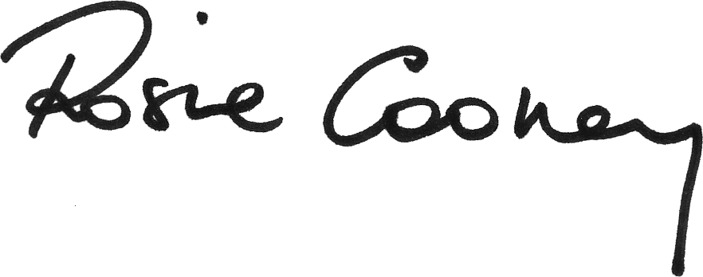
Dr Rosie Cooney

IUCN (2013) CITES CoP 16 Inf. 51. Online at http://www.cites.org/eng/cop/16/inf/E-CoP16i-51.pdf
Ibid.
See e.g. Weaver LC, Hamunyela E, Diggle R, Matongo G and Pietersen T (2011). The catalytic role and contributions of sustainable wildlife use to the Namibia CBNRM Programme. In CITES and CBNRM: Proceedings of an international symposium on "The relevance of CBNRM to the conservation and sustainable use of CITES-listed species in exporting countries". M. Abensperg-Traun, D. Roe and C. O'Criodain (Eds). Gland, Switzerland and London, UK, IUCN and IIED: 59-70. Online at http://pubs.iied.org/14616IIED.html
NACSO. 2013. The state of community conservation in Namibia - a review of communal conservancies, community forests and other CBNRM initiatives (2012 Annual Report). NACSO, Windhoek. Online at http://www.nacso.org.na
See examples in IUCN SSC (2012) Guiding Principles on Trophy Hunting as a Tool for Creating Conservation Incentives v1, Annex 1. Online at http://cmsdata.iucn.org/downloads/iucn_ssc_guiding_principles_on_trophy_hunting_ver1_09aug2012.pdf
This figure is calculated very conservatively as follows: Namibian communal conservancies have 573 full time and 96 part time conservancy employees, plus 862 conservancy representatives who receive allowances (NACSO 2013, see n4). While all of these people contribute to promoting conservation, of the full time Conservancy employees at least 460 are community game guards. There are over 1500 registered hunting farms in Namibia (freehold land), and it can be conservatively assumed that each farm employs 2 game guards. This supports a total of at least 3460.
IUCN (2013) see above, n1.
IUCN (2000) Policy on Sustainable Use of Wild Living Resources, WCC Res. 2.29. Online at http://www.iucn.org/about/union/commissions/sustainable_use_and_livelihoods_specialist_group/resources/res_supolstat/
IUCN (2004) Application of the IUCN Sustainable Use Policy to sustainable consumptive use of wildlife and recreational hunting in southern Africa WCC Rec 3.093. Online at https://portals.iucn.org/library/efiles/edocs/WCC-3rd-005.pdf
IUCN SSC (2000) supra n5.
IUCN (2012) Conservation of rhinoceros species in Africa and Asia. WCC Rec. 138. Online at http://www.rhinos.org/Assets/wcc-2012-rec-138-en-conservation-of-rhinoceros-sp.pdf

