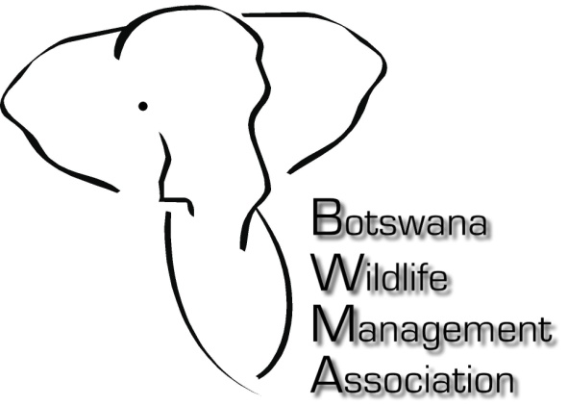

HUNTING IN BOTSWANA - STATEMENT TO VALUED CLIENTS, AGENTS AND FRIENDS
Over the last 5 years, Botswana’s trophy hunting industry has been subjected to some extensive changes to areas available for hunting, and changes in land use in other areas where photographic and hunting operations have been combined – these changes have given rise to much speculation amongst the international hunting fraternity: the Botswana Wildlife Management Association wishes to confirm that from the end of this year big game hunting will continue in the following concessions:
Butler & Holbrow Safaris / Chobe Enclave CH1/2 – end of 2013
Calitz Hunting Safaris / Mababe NG 41 – end of 2017
In spite of draconian cuts in quota for other species, elephant remain the flagship species in Botswana and sustainable offtake of this species will continue under the guidance and direction of the Botswana Government. Recent aerial surveys conducted by independent researchers, in collaboration with Government and the Association, have determined that the Botswana elephant population is stable and in some parts of the country are considered locally over-abundant. The Special Elephant Quota, which is auctioned annually to industry members and stakeholders, will continue in select areas for the benefit of local communities and for elephant conservation and management as a whole. Private research on tusk weights/population distribution and densities, supported by outfitters, is ongoing and will continue to inform Botswana’s wildlife Management Authority.
Assurances have been made to the industry by senior members of Government during the course of the last five years that elephant hunting will continue in Botswana; in the meantime, outfitters remain committed to ongoing discussion and consultation with Government to determine the way forward. Hunting on game ranches is unchanged. Please contact your safari outfitter or the Botswana Wildlife Management Association (botswanawildlife@yahoo.com or debbie@mochaba.net) for any further information or confirmation you may require.

27 March, 2012

The Botswana Wildlife Management Association
Private Bag 098 Maun Botswana Tel: + 267 6862 671 Fax: + 267 6862671

